2.1 Design and performance Evaluation of a Chebyshev Type I IIR Low Pass Filter using MATLAB

CODING:
clc;
clear;
close all;

% Specifications
Rp = 1; % Passband Ripple (dB)
As = 40; % Stopband Attenuation (dB)
Wp = 0.4; % Passband Edge
Ws = 0.6; % Stopband Edge

[N,Wn]=cheb1ord(Wp,Ws,Rp,As);
[b,a]=cheby1(N,Rp,Wn);

fprintf('Filter Order = %d\n',N);
fprintf('Cutoff Frequency = %.2f * pi rad/sample\n',Wn);

if all(abs(roots(a))<1)
disp('System is STABLE');
else
disp('System is UNSTABLE');
end

% -------- GRAPHS --------
figure;
freqz(b,a); % Magnitude + Phase

figure;
impz(b,a); % Impulse Response

figure;
grpdelay(b,a); % Group Delay

figure;
zplane(b,a); % Pole-Zero

OUTPUT: 1
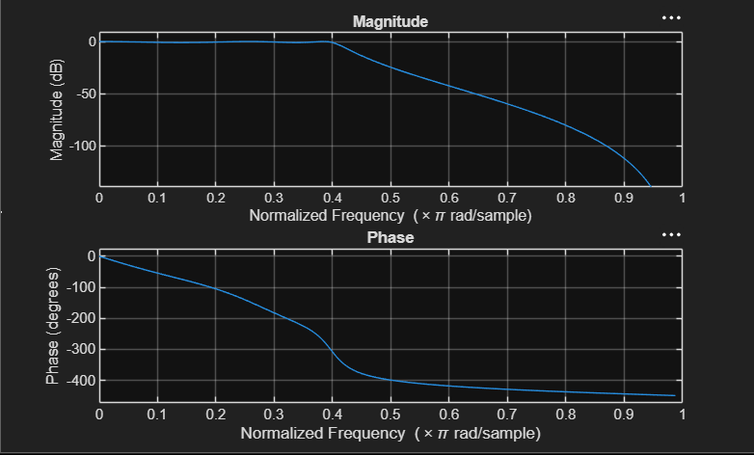

OUTPUT: 2

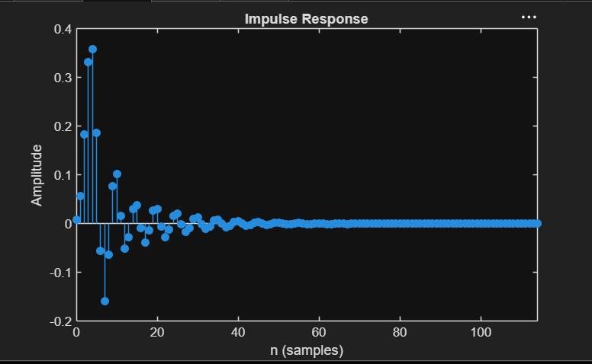

OUTPUT: 3
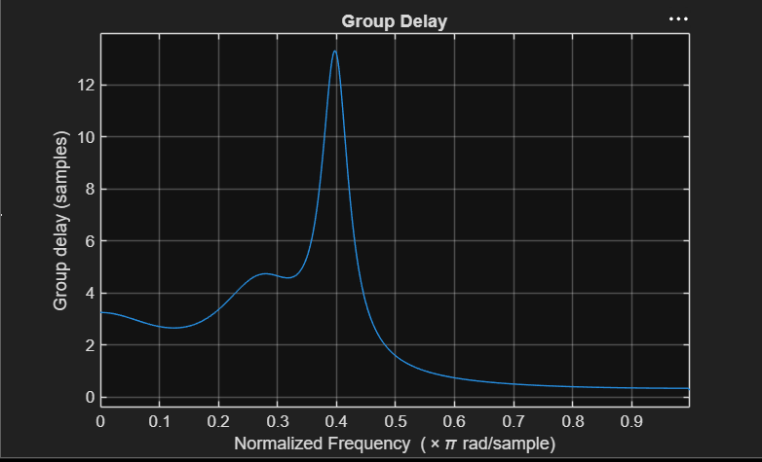

OUTPUT: 4
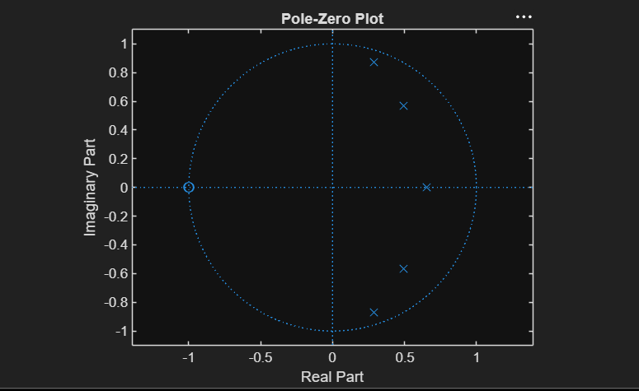

RESULT:
Filter Order = 5
Cutoff Frequency = 0.40 * pi rad/sample
System is STABLE

